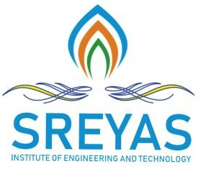Sreyas Institute of Engineering and Technology

***An Autonomous Institution***

Approved by AICTE, Affiliated to JNTUH

Accredited by NAAC-A Grade, NBA (CSE, ECE & ME) & ISO 9001:2015 Certified

DEPARTMENT OF ELECTRONICS AND COMMUNICATION ENGINEERING

Date:15/05/2025

# Gas leakage, Fire and Smoke Detection System with Alarm and SMS Alert

**Abstract**

This project presents a smart safety system that uses integrated sensors to detect gas leakage, fire, and smoke. The system employs gas sensors (such as MQ series), flame sensors, and smoke sensors to monitor environmental conditions in real time.

If any hazardous event is detected, the system triggers a local alarm and sends an SMS alert to registered users via a GSM module. This provides immediate notification both on-site and remotely, allowing users to act quickly.The system is ideal for residential, commercial, and industrial settings, where early detection of hazards can prevent serious accidents and damage. Its key features include reliability, cost-effectiveness, and ease of installation, making it a practical safety solution for various environments. By integrating sensors with communication technology, the system ensures timely alerts, enhancing safety and minimizing risks. This proactive approach helps safeguard lives and property by providing instant warnings of potential dangers, ensuring prompt action can be taken.

**Keywords:** Smoke detection, safety system, real-time monitoring, sensor network.

(T M CHANDANA - 22VE1A04C1)

(M NAREAN - 22VE1A0493)

(K SHYAM - 22VE1A0488)

Signature of the Guide IOMP Coordinator Head of the Department